Copy & Paste Instructions
This document has been created in order to ensure that when students’ details are copied and pasted from other spreadsheets onto the confirmation template, only the information we require is pasted rather than all of the formulas from the other spreadsheet. Please always use this method when copying and pasting student’s details onto the confirmation template.
Instead of cutting/copying and pasting you should copy, then when you paste, instead of just pasting you should paste the values only. This will allow you to paste in the data without copying in all of the formatting from another spreadsheet. This may not be an issue if you are going to be using our 2019/20 template as your 'master' for the 2019/20 year as they will have the same formatting however I would always advise to paste values only just to make sure.
There are two ways you can do this. Option 1 is after copying the data you need, right click into the cell you want to start pasting and select the 'paste special' option then select 'values' and hit OK.
This will look like:
Step 1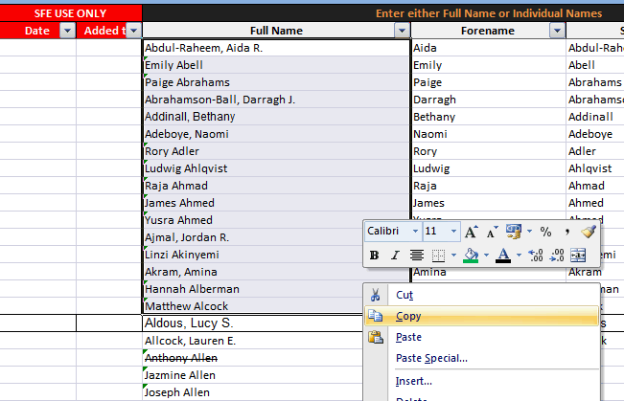

Step 2
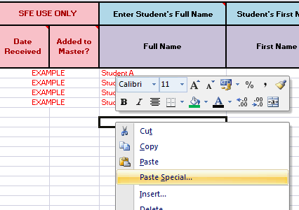

Step 3
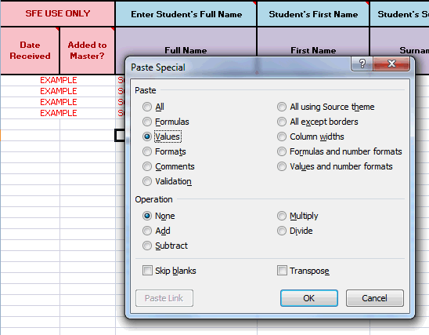

Result:
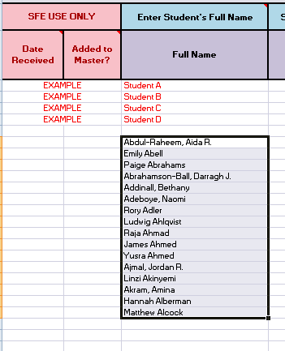
Option 2 which is a little bit easier in terms of mouse clicking would be to copy the data as per step 1 then instead of right clicking the cell in step 2 you would left click to highlight the cell you wish to paste in then press the arrow underneath the paste button in the top left corner on the spreadsheet (home tab) and click values.

This will look like:
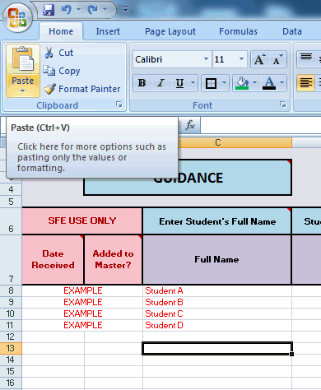
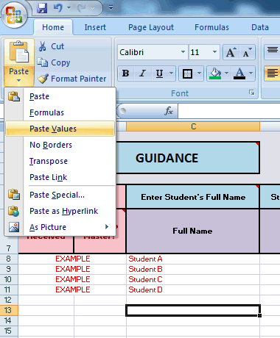
Result:
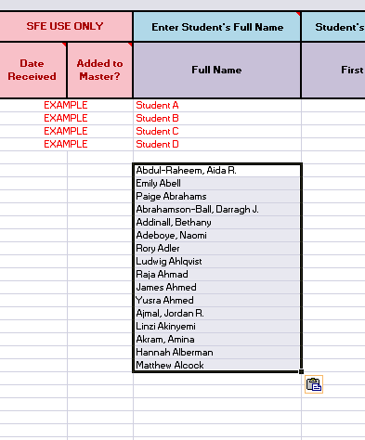

If you follow this process for all of the information that is copied and pasted onto the template you shouldn't have any issues with formatting and the template will also then be able to pick up the duplicates.

